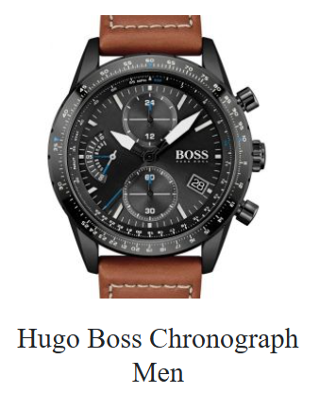

**Product Name:**

Hugo Boss Chronograph Men

**Description:**

Is watch ka **black dial** hai, jisme **multiple sub-dials** aur **date display** shaamil hain. **Brown leather strap** isay ek elegant touch deta hai, jo casual aur formal dono occasions ke liye perfect hai.

**Specification:**

* **Brand:** Hugo Boss
* **Model:** Chronograph Men
* **Dial Color:** Black
* **Strap Material:** Leather
* **Strap Color:** Brown
* **Functions:** Chronograph, Date Display
* **Display Type:** Analog

**Price:**

PKR 38,350